**SECURE HOME AUTOMATION USING RASPBERRY PI BY TELEGRAM APP**

Mr. G. Nageswara Rao (ASSOCIATE PROFESSOR)1

Gandham Harshitha (19K61A1215)2, Nimmala Akanksha (19K61A1240)3,

Adapareddy Harika (19K61A1201)4

1,2,3,4DEPARTMENT OF INFORMATION TECHNOLOGY, INDIA,

SASI INSTITUTE OF TECHNOLOGY & ENGINEERING

**Abstract: In today’s generation dealing with security vulnerabilities on all sides. So, we must use streamlined technology to address these problems. In this project, we'll be taking pictures of people and comparing them to images from the database that have already been stored. Finding out who enters or leaves the property is the most crucial feature of any home security system. Unique faces can be used to monitor things instead of passwords or pins because they are a person's biometric feature. We want to create a smart door that protects the doorway based on who we are. By employing facial detection and identification, this initiative aims to assist users in enhancing the door security of critical locations. If an unauthorised face is automatically detected, the system will take a picture and send it to the appropriate person by telegram.**

**Keywords: Facial detection, database, doorway, telegram.**

1. **INTRODUCTION**

In this system, an IR sensor is employed to determine any motion at the front door, which activates the camera and causes it to take the picture and send it to the owner by telegram. If the database contains visitor image information, the door will automatically open otherwise the owner will receive the image of an intruder and can choose whether or not to let admission. Our suggested approach leverages Telegram notification to alert the owner, in contrast to existing notification systems. The benefit of utilising Telegram is that some older citizens do not use Gmail or Twitter because they find those services difficult to use and necessitate the setup of accounts. Since Telegram is a messaging programme that can operate online in a similar way to WhatsApp, the majority of elderly folks want to use it. The primary goal of this study proposal is to develop and deploy a low-cost, secure, and adaptable home automation system that is capable of security employing face detection and motion detection systems that are also used for home automation.

1. **LITERATURE REVIEW**

Dashi, Deep and Rai et al [1] Technology alters people's daily routines, An android app is created to assist old individuals who are unable to aid themselves, and this created system is used by people who live alone. This system's implementation makes use of WIFI and an easy-to-use web server, both of which have the potential for future growth when combined with improved sensors to boost sensor precision (like up to street Nights)

Dhiraj and Ramana et al [2] Users can access household equipment at any time by connecting to the network and controlling them as necessary. This system also offers security as it sends an email notice to the user when it detects an intruder or person. The system is operated via a web page and a telegram bot.

Bhavyasri, Neha, Pranaya and Manoj et al [3] technology that automates your home that combines many technologies, such as the Internet of Things. The primary benefit of this system is that it offers users both text and voice communication options. A chatbot application will be used for the user's text input, and a voice assistant will be used for the user's voice input.

Kamal, Biswas and Sayidul et al [4] a security hierarchy of three have been guaranteed. Use of NFC tags with a PIR motion sensor and a password. The door won't open if one of them isn't there. A lock is attached to the shaft of the servomotor that will be used to unlock the door. When the incorrect password is entered, the LCD shows error text.

Sudha and Priya et al [5] By managing and interacting with remote control of home appliances, the IOT offers a comfortable way of living to people. Two Node MCUs are present in the proposed system. The Node MCU (Node unit micro controller) is an open-source device that combines hardware and software to create a far less expensive system based on the ESP8266 chip.

Apeksha and Bhacheh et al [6] While an automated home can be referred to or classified as a smart home, a system for wireless home automation employing the iot employs computers or mobile devices to operate features automatically through the internet from anywhere in the globe.

Ruhi et al [7] These systems often include a detecting and actuation layer made up of passive infrared sensors, also referred to as motion sensors, and web cameras for security.

Akash and Priyanka et al [8] In this system, devices including lighting, fans, and camera access are employed. Any internet-capable device, such as a smart phone or laptop, may be used to control home appliances thanks to an Android application and a Telegram bot. Additionally, the proposed system offers home security by using a camera that can send photos via a Telegram bot message when there are one is home.

Mohan, Samir, Nihar et al [9] To serve as a connectivity module to show the system's effectiveness and viability. It enables the user to remotely manage a variety of appliances, including lights, fans, and televisions, as well as make decisions based on sensor feedback on various environmental factors.

G. joga and Vinod et al [10] The study is primarily focused on IOT-based home automation utilising a wireless raspberry PI system. IOT enables we can use to automatically control standard household equipment via the internet from anywhere in the world using PCs or mobile devices.

Shaik, Krishna et al [11] These days, everything moves at supersonic speeds, and digital media allows for data to be exchanged at the speed of light. Therefore, utilising Internet protocols, information must come in at the same rate.

Desai, Virendra et al [12] The IoT is at its height in the modern world. As the world becomes smarter, home automation is starting to take off. One of the newest technologies in home automation is smart door control. This study seeks to expand the door automation method utilising a Raspberry Pi and an Android device.

Shakthi and Abishiek et al [13] A smart home is a networked association of automation and management for extraordinary living. Home security is crucial in this regard, becoming a crucial aspect of our lives.

Reeta R et al [14] The facial recognition technology works by first taking a picture with a camera. The snippet of code recognises an individual's characteristics. Using a Raspberry Pi, the captured image is compared to the database of photos after being detected. The faces are then compared to see if they match or not. After that, if an intruder tries to enter the premises, the SIM300 GSM module transmits a security alert to the designated person.

Akash Kasote , Priyanka Kolage , Nikita Sadgir , Gayatri Avhad, Dr. P.G.Vispute et al [15] Our project aims to create devices that are simple to operate, including home applications and other devices. Using an application on a cell phone with an Android, iOS, or Windows operating system installed, we may operate fans, air conditioners, lights, and other appliances.

Yasirli Amri , Mukhammad Andri Setiawan et al [16] Email was the basis on which the smart home was formed. This research examined a home security system that identifies facial patterns to allow access. Cameras and a BeagleBone are used in this system. Email was used by the system to interact with users.

K. H. Shakthi, P.Abisheik, V.Srinath, S.Dinakaran, M.Ajay et al [17] The database contains pictures of people who have been granted approval. The camera records the face of the person who rings the doorbell when they approach the door and compares it to previously recorded photographs in the database. The door unlocks if the image is a match with the one being captured at the moment. If it fails, the user receives the captured face.

Rajiv Kumar, Pooja Mittal et al [18] The system includes a backup in case there is a power outage issue. The power backup devices are switched in place of the main supply, and they continue to power the security system.

Simge Demir Şevval Şimşek et al [19] The goal of their future study is to create an anonymous secure framework (ASF) for smart homes. The ASF model focuses critical progression on session and routine key renewal to get rid of any faults brought on via a falsified key. Although this model offers unlinkability and anonymity, it is missing the property of anonymous identification.

Olutosin Taiwo **Absalom E. Ezugwu et al [20] To make efficient use of energy, the mobile application allows you to turn any electrical home device ON or OFF. It analyzes the home's current humidity and temperature and alerts the user. It also direct conversion readings of the activities taking place at home and stores or gets the data to or from the cloud.**

**REFERENCE WORK:**

|  |  |  |  |  |  |
| --- | --- | --- | --- | --- | --- |
| **R. No.** | **TITLE** | **AUTHOR** | **YEAR** | **METHODOLOGY** | **LIMITITATIONS** |
| [1] | “IoT Home Automation” | Dashi, Deep and Rai | 2021 | Arduino, Relay, Led,  Fan, Node MCU is used for automation | Security, privacy, and designing, developing the system is very complex |
| [2] | “Webpage And Telegram Bot Controlled Home Automation System” | Dhiraj and Ramana | 2020 | Three 2-channel relays, two fans and 2 light ,electromagnetic door lock, The PIR Sensor , GPIO pins | SMTP server updation can be delayed as usage Of Raspberry Pi makes it more complex as detection of Intrudution Send mail. (It can be enchanced further). |
| [3] | “Home Automation Using Chatbot And Voice Assistant” | Bhavyasri, Neha, Pranaya and Manoj | 2020 | Raspberry Pi NLP unit: natural language processing Spoken-to-text conversion will be applied to the Voice Assistant module's speech input. processing, hence providing a text input to the NLP module, The entire processing of the acquired input hap-pens in this unit. | The system can be further made inclusive of extensions such as attaching of email services as an alternate form of message delivery, in situations of utmost importance. The number of devices that can be connected to the system can not be expanded to a larger range. |
| [4] | “Design And Implementation Of Smart Home Security System” | Kamal, Biswas and Sayidul | 2020 | PIR sensor, pin, servo motor ,buzzer ,VDD ,  VSS ,power supply crystal oscillator set of authorized person data microcontroller sends signal to servo motor | Developing the system is very complex which leads to not reachong all the features. |
| [5] | “Iot Based Smart Security And Smart Automation” | Sudha and Priya | 2020 | Remotely controlled room temperature, automatic fans, and automatic lights | Security ,privacy, and designing, developing, managing the system . |
| [6] | “Home Automation And Security Using Iot” | Apeksha and Bhacheh | 2020 | Drivers/devices, sensors, Wi-Fi router mobile ESP8266 node MCU Wi-Fi Module, Relay Module, DHT11, Current Sensor configure ESP8266 . | This concept combines home automation and security, both of which are necessary nowadays. . |
| [7] | “Iot Based Smart Security And Home Automation” | Ruhi Uzma , Prafulla Anil | 2021 | NodeMCU , ArduinoNano , Relay  LCD , DHT11 sensor, MQ9 Gas sensor , Touch Sensor, Buzzer Operation Voltage, | IoT digital code lock security is provided as an advanced feature. |
| [8] | “Smart Home Automation Via Telegram Chatbot And Android Application” | Akash and Priyanka | 2021 | Telegram , Telegram bot, Bot Father , The Raspberry Pi , Temperature sensor DHT11, Pi Cam | Computer vision can be used for motion detection and alerting through telegram |
| [9] | “Arduino Based Home Automation Using Internet Of Things (Iot)” | Mohan, Samir, Nihar | 2018 | Arduino UNO , 4-Channel Relay , ESP8266-01, WIFI, Gas Sensor , Temperature Sensor, Software Design , Implementation , | reducing the time it takes an appliance to switch on and off, Adding speech recognition to the system, utilising Wi-fi to detect smart phones automatically so that the loads are activated when they are in range, Wi-Fi range expansion to allow for operating across great distances that are acceptable |
| [10] | “Iot Based Web Controlled Home Automation Using Raspberry Pi” | G. joga and Vinod | 2019 | Raspberry pi , Voltages , SPI , I2C, Serial, Camera , Pir sensor , Relay module, Digital humidity and temperature sensor , door sensor | Security ,privacy, and designing ,developing the system is very complex |
| [11] | “Home Security And Automation With Telegram Communication Application Using Raspberry Pi” | Shaik, Krishna | 2021 | Telegram protocol, Remote Support, Meetings Presentations, Remote Access Remote Office Remote Home, Home electronics unit (HEU) , Telegram application unit (TAU), | SMTP server updation can be delayed as usage Of Raspberry Pi makes it more complex as detection of Intrudution Send mail. (It can be enchanced further) |
| [12] | “Smart Door Security System Using Raspberry Pi With Telegram” | Desai, Virendra | 2020 | Raspberry pi B3 , PIR Sensor , Camera Module ,Wi-Fi Module .Telegram App | The system can be further made inclusive of extensions such as attaching of email services as an alternate form of message delivery, in situations of utmost importance. The number of devices that can be connected to the system can not be expanded to a larger range. |
| [13] | “Implementation Of Advanced Smart Home Security Alert System” | Shakthi and Abishiek | 2019 | facial recognition, Raspberry Pi 3, camera module, door lock, automation, security | Developing the system is very complex which leads to not reachong all the features |
| [14] | “Smart Secure Door Lock System Using Iot And Eigenface Approach” | Reeta R | 2017 | IoT, Wi-Fi modem, relay, Python, Eigenface, Raspberry Pi | The development of an interactive smart home security system with the raspberry pi, Web-based control systems and using the Eigenface technology |
| [15] | “Smart Home Automation Via Telegram Chatbot And Android Application” | Akash, Priyanka Kolage, Sadgir | 2021 | Home automation, Home security, Internet of Things, Python language, Raspberry Pi3, Android, Telegram Bot | Computer vision can be used for motion detection and alerting through telegram. |
| [16] | “Improving Smart Home Concept With The Internet Of Things Concept Using Raspberrypi And Nodemcu” | Yasirli Amri , Mukhammad Andri Setiawan | 2017 | Raspberry Pi ,NodeMCU, rain sensor, door sensor, passive infrared sensor (PIR), DHT22 | Improve home security The system does not require a great power Users can control and monitoring the house remotely |
| [17] | “Implementation Of Advanced Smart Home Security Alert System” | K. H. Shakthi Murugan , P.Abisheik, | 2019 | facial recognition, Raspberry Pi 3,camera module, door lock, automation, security | Developing the system is very complex which leads to not reachong all the features. |
| [18] | “A Novel Design And Implementation Of Smart Home Security System: Future Perspective” | Rajiv Kumar, Pooja Mittal | 2019 | Security, sensors, Internet of Things (IOT), and GSM (Global System for Mobile Communication) | This security system has generic concept and implementation with effective GSM to notify users with message with raising alarm. |
| [19] | “Secure And Iot Gateway For Home Automation” | Simge Demir Şevval Şimşek | 2020 | IoT device, Vendor, Nonce with identifier | Security ,privacy, and designing, developing, managing the system . |
| [20] | “Internet Of Things-Based Intelligent Smart Home Control System” | Olutosin Taiwo **Absalom E. Ezugwu** | 2021 | sensors, an ESP32-CAM board, a 5 V, 4-channel relay module, and an ESP8266 board. | The home automation system allows remote and local control of the home. The system controls electrical home appliances, monitors environmental conditions through temperature, humidity, and light sensors, and ensures home security through a motion sensor and an IoT camera |

1. **BLOCK DIAGRAM**

This proposal makes use of a number of other modules, including Telegram and

image processing, to improve interaction with home security systems. We require both hardware and software codesign in order to create secure home systems. We require a microcontroller in the hardware to manage the system's general operation. Servo motors and LED actuators are employed, Here, load is a representation of how various home applications are connected to the system to become automated.

Figure 4.1: General scenario

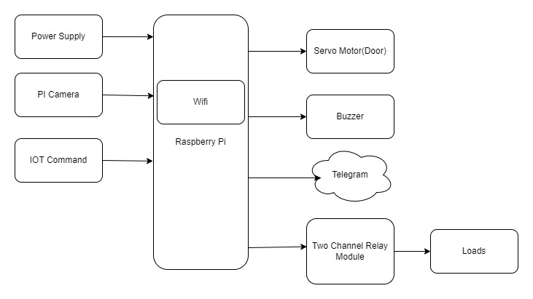

Figure 3.1: Basic flow of the system

1. 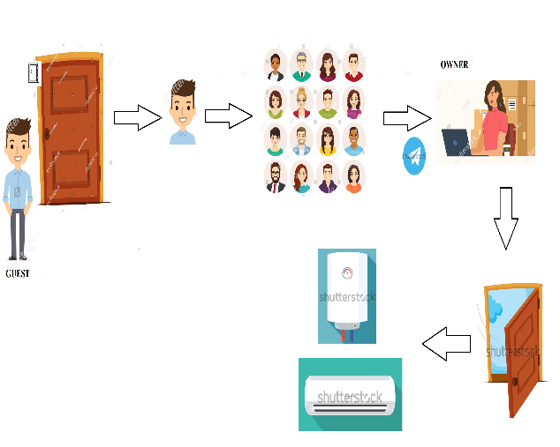**GENERAL VIEW**

As seen in the above graphic, when a visitor's image cannot be matched with photographs already in the file storage, the owner is prompted to open the door by determining whether the visitor is a recognised individual before the automation of the home activities are carried out.

1. **METHODOLOGY**

Hardware requirements, software requirements, and user requirements are necessary for the proposed system's implementation design. The suggested system's control flow is depicted in the

Hardware Components:

* **Raspberry Pi**

The Raspberry Pi Foundation created the single-board computer, or tiny circuit, to enable teaching programming to novices.

* **USB Camera**

A camera that connects to a computer by typically being plugged into a USB port on the device is known as a USB webcam. The computer receives the video feed, and a software programme allows you to view the images and upload them to the Internet.

* **Sd card**

A Secure Digital (SD) card is a small flash memory card made for high-capacity storage and a variety of portable devices, including GPS navigation systems, cell phones, e-books, PDAs, smartphones, digital cameras, music players, digital video camcorders, and personal computers.

Figure 6.1: Level 0 DFD

* **Servo Motor(door)**

The control circuit for this type of motor often offers feedback on the motor shaft's present position, enabling the servo motors to rotate very precisely.

* **Buzzer**

a signalling tool that uses electricity and generates a buzzing noise.

* **Jumper wires**

Figure 6.2: Level 1 DFD

An electric line known as a jumper wire is used to connect distant electric circuits on printed circuit boards.

Software Components:

* IDLE Software
* Python language

1. **DFD DIAGRAMS**

**DFD Level 0**

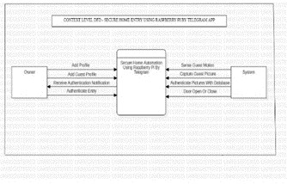It is intended to be an abstraction view that presents the system as a lone process with its connections to outside entities. It depicts the complete system as a single bubble with incoming/outgoing arrows designating input and output data

**DFD Level 1**

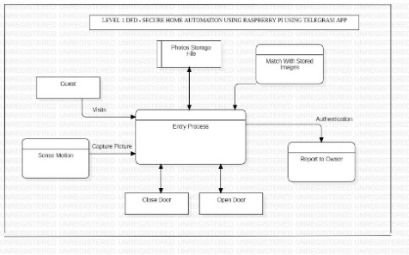The Contextual diagram is divided into numerous processes in 1-level DFD. This level emphasises the, we highlight the key operations of the system and decompose the high-level 0-level DFD process into subprocesses

The Contextual diagram is divided into numerous processes in 1-level DFD. In this level, we emphasises the key operations of the system and decompose the high-level 0- level DFD process into subprocesses.

**DFD Level 2**

Figure 6.3: Level 2 DFD

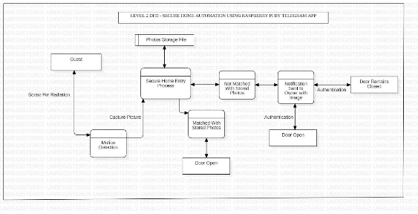Parts of 1-level DFD are further explored in 2-level DFD. It can be used to plan or keep track of the precise or important information about how the system works.

1. **FUTURE SCOPE**

We have created a smart system that minimises human effort and makes it simple to operate the smart door. This system allows access from anywhere in the world while still offering high security. Both upgrading and portability are simple. By sending a reply message to RPI, By using Telegram, the owner of the smart door lock system can unlock the door and grant access to a known person.

1. **CONCLUSION**

The Iot and image processing are two cutting-edge technologies that are used in this idea for a high level of security. The suggested work is implemented utilising a Raspberry Pi, which can connect to a computer or a mobile device, making it simple for the user to utilise. Our technology, which uses an IR sensor for object detection and a camera for face identification, is an integrated response to all previous work.

1. **REFERENCES**

[1] Dashi, Deep and Rai “Iot home automation” Research gate Conference on Recent Trends in Electronics, Information & Communication Technology, august 2021 https://www.researchgate.net/publication/353789495

[2] Dhiraj and Ramana “Controlled by a website and a Telegram bot, the home automation system” international journal of scientific & technology research volume 9, issue 02, february 2020

[3] Bhavyasri, Neha, Pranaya and Manoj “home automation using chatbot and voice assistant” tm web of conferences 32, 01002 (2020) https://doi.org/10.1051/itmconf/20203201002

ICACC-2020

[4] Kamal, Biswas and Sayidul “ design and implementation of smart home security system” <https://www.researchgate.net/publication/293173717> ,December 2020

[5] Sudha and Priya “iot based smart security and smart automation” <https://www.researchgate.net/publication/332295600> , March 2021

[6] Apeksha and Bhacheh “ home automation and security using iot ” international journal of creative research thoughts, volume 8, July 2020

[7] Ruhi “a review on iot based smart security and home automation” international journal scientific research and technology” [https://doi.org/10.32628/IJSRST2183159 , volume](https://doi.org/10.32628/IJSRST2183159%20,%20%20volume) 8 ,June 2021

[8] Akash and Priyanka “Smart Home Automation via Telegram Chatbot and Android Application” IJARIIE-ISSN(O)-2395-4396 Vol-7 Issue-3 2021 [www.ijariie.com](http://www.ijariie.com)

[9] Mohan, Samir, Nihar “ Arduino based home automation using Internet of things (IoT) “ International Journal of Pure and Applied Mathematics Volume 118 No. 17 2018, 769-778 ISSN: 1311-8080 (printed version); ISSN: 1314-3395 (on-line version) url: <http://www.ijpam.eu>

# [10] G. joga and Vinod “Iot based web controlled home automation using raspberry pi” March 2019 <https://www.researchgate.net/publication/332295600>

# [11] Shaik, Krishna “Home Security and Automation with Telegram Communication Application using Raspberry Pi” An international open access, peer reviewed, reference journal July 7 [www.ijcrt.org](http://www.ijcrt.org)

# [12] Desai, Virendra “Smart Door Security System using Raspberry Pi with Telegram” International Research Journal of Engineering and Technology (IRJET) Volume: 06 Issue: 06 June 2020 , [www.irjet.net](http://www.irjet.net)

# [13] Shakthi and Abishiek “Implementation of Advanced Smart Home Security Alert System” IJSRCSAMS Volume 8, Issue 2 March 2019 www.ijsrcsams.com

[14] Reeta R “ smart secure door lock system using iot and eigenface approach ” IJCRT Volume 5, Issue 4 December 2017

[15] Akash Kasote , Priyanka Kolage , Nikita Sadgir , Gayatri Avhad, Dr. P.G.Vispute “Smart Home Automation via Telegram Chatbot and Android Application” IJARIIE Vol-7 Issue-3 2021

[16] Yasirli Amri , Mukhammad Andri Setiawan “Improving Smart Home Concept with the Internet of Things Concept Using RaspberryPi and NodeMCU ” ICITDA 2017

[17] K. H. Shakthi Murugan , P.Abisheik, V.Jawhar Srinath, S.Dinakaran, M.Ajay Kumar “Implementation of Advanced Smart Home Security Alert System” International Journal of Scientific Research in Computer Science Applications and Management Studies Volume 8, Issue 2 March 2019

[18] Rajiv Kumar, Pooja Mittal “A Novel Design and Implementation of Smart Home Security System: Future Perspective” International Journal of Applied Engineering Research ISSN Volume 14, Number 2 2019

# [19] Simge Demir Şevval Şimşek “Secure and privacy preserving IoT gateway for home automation”  International Conference on Security of Information and Networks, SINCONF 2020 <https://doi.org/10.1016/j.compeleceng.2022.108036>

# 

[20] Olutosin Taiwo **Absalom E. Ezugwu** “Internet of Things-Based Intelligent Smart Home Control System**” Research Article | Open Access** Volume 2021 Article ID 9928254 <https://doi.org/10.1155/2021/9928254>